# 

1 HIGHLIGHTS 1

2 COLLEGE SYSTEM REVENUES AND EXPENSES 2

2.1 College system revenues 2

2.2 College system expenses 3

2.3 Accumulated surplus, Ontario colleges 4

3 TRENDS IN COLLEGE FUNDING 5

3.1 Enrolment and revenue changes 5

3.2 Estimated grant and tuition fee revenue per college student by province 6

3.3 Operating funding and regulated tuition fees per student, Ontario education sectors 7

3.4 Square metres per student, Ontario education sectors 8

3.5 Summary of apprenticeship per diem history 9

**4 HUMAN RESOURCES TRENDS**……..………………………………………………………....….………………………….……..….. 10

4.1 College staffing levels 10

4.2 Number of full-time college staff by category 10

5 STUDENT FINANCIAL AID 11

5.1 Levels of student assistance and number of recipients, college sector 11

5.2 Canada-Ontario Integrated Student Loan default rates 12

6 APPENDICES 13

6.1 Appendix 1. Operating grants and regulated tuition fee revenue per FTE 13

6.2 Appendix 2. Number of college student assistance recipients, by student type 14

6.3 Appendix 3. Average student assistance issued to college students, by student type 14

6.4 Appendix 4. Distribution of student assistance recipients by post-secondary sector and student group 15

# HIGHLIGHTS

* Like many organizations around the world, Ontario’s colleges had to adapt to a challenging and unpredictable environment during the pandemic.
* Many college programs quickly shifted to online learning. A wide range of support services also had to move to virtual delivery, requiring new investments in technology and other investments.
* Where activities on campus were required, practices were adapted to maintain a safe working and learning environment. Many ancillary operations and activities were cancelled or scaled down, which affected services and the resources required to deliver these services.
* These factors increased the costs for colleges throughout the period covered by this environmental scan. In addition, the unpredictable course of the pandemic and changes in public health requirements all created an extremely challenging environment for planning and delivering critical college services.

Revenues and expenses

* Colleges have continued to deliver quality programs, supported by fees from international students. However, auditor general Bonnie Lysyk warned in her 2021 annual report the colleges’ fiscal situation is “risky.”
* If international enrolment trends should change, many colleges would face significant fiscal challenges.
* In fact, total college system revenues declined from $5.5 billion in 2019-20 to $5.1 billion in 2020-21. Domestic tuition revenue declined by six per cent while international tuition revenue declined by three per cent in 2020-21 relative to 2019-20. Grant revenue from all sources accounted for only 38 per cent of college system revenue.
* College system expenses declined from $5.2 billion in 2019-20 to $4.9 billion in 2020-21. The decline is due to the scaling down of some operations and activities occasioned by the COVID-19 pandemic.
* As of March 2021, the college system had an accumulated surplus of $3.1 billion. About 60 per cent of this surplus has been invested in capital assets.

Trends in college funding

* At $5,068, the real operating grants per full-time equivalent (FTE) student in 2020-21 were approximately six per cent higher than in 2004-05 ($ 4,801) and 11 per cent lower than the peak of $5,673 in 2007-08.
* Per student revenue from operating grants and tuition fees for Ontario colleges is the lowest among the provinces. Funding per student for Ontario colleges is significantly lower than for secondary schools and universities.
* Space per student is much lower for Ontario colleges (7.5 square metres per student in 2019) in comparison to universities and secondary schools and is in fact lower than it was in 2012.
* While the apprenticeship per diem in current dollars in 2020-21 is higher than it was in 2004-05, it is 7 percent lower than it was in 2004-05, when inflation is considered. The in-school student fee of $10 per student has not increased since it was introduced in 2002-03.

Human resources

* Colleges employ almost 44,000 full-time and part-time people. From 2004-05 to 2020-21, the number of full-time staff employed at colleges increased by 33 per cent.

Student financial aid

* In 2020-21, about 131,000 college students were OSAP recipients. This represents 74 per cent of the total full-time post-secondary enrolment.

# COLLEGE SYSTEM REVENUES AND EXPENSES

## 2.1 College system revenues, 2020-21

|  |  |
| --- | --- |
| *Includes apprenticeship classroom fee.  **Includes private partnership revenue.  ***Includes contractual educational services, other fees for services and other revenues.  Source: Ontario Ministry of Colleges and Universities, CFIS.  Prepared by Colleges Ontario. |  |

* In 2020-21, grant revenue from all sources accounted for 38 per cent of college system revenues.
* Revenue from domestic and international tuition fees as a proportion of total system revenue is the highest, relative to revenue from grants, ancillary fees and other revenue.

## 2.2 College system expenses, 2020-21

|  |  |
| --- | --- |
| *Includes amortization expense.  Source: Ontario Ministry of Colleges and Universities, CFIS.  Prepared by Colleges Ontario. |  |

* College system expenses include items such as amortization expenses, contract services, scholarships and student assistance from the tuition set-aside.
* Like most organizations in both the public and private sectors, compensation costs – salaries and benefits together – are the largest expense item for colleges.

## 2.3 Accumulated surplus, Ontario colleges 2020-21

|  |  |
| --- | --- |
| Note: As of March 2021.  Source: Ontario Ministry of Colleges and Universities, CFIS.  Prepared by Colleges Ontario. |  |

* As of March 2021, the college system had an accumulated surplus of $3.1 billion. Two-thirds of this surplus – $1.9 billion – has been invested in capital assets. The funds have been used for major building projects and to purchase major assets such as lab equipment.
* One-third – $1.1 billion – falls into the unrestricted and internally restricted net assets category. Net assets in this category are used for a variety of purposes and future needs that include:
* Providing stability to ongoing operations.
* Responding to one-time evolving and emergent needs.
* Funding long-term and ongoing capital commitments.
* Strategic initiatives, including expansion and innovation.

# 3 TRENDS IN COLLEGE FUNDING

## 3.1 Enrolment and revenue changes, 2004-05 to 2020-21 (indexed to 2004-05)

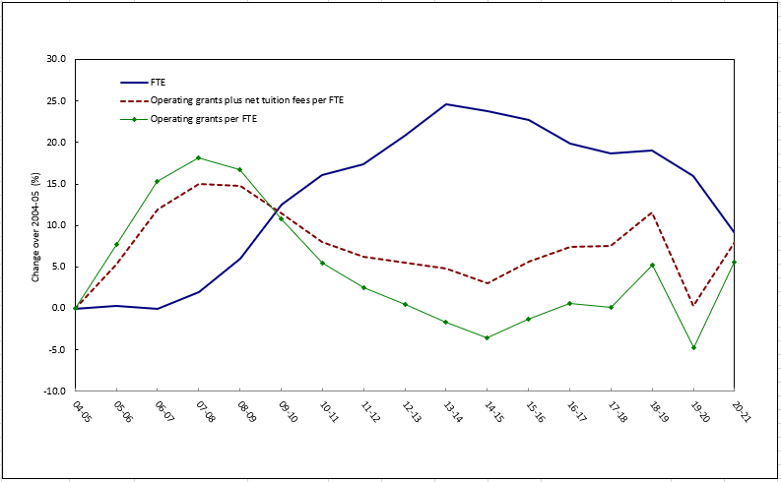

|  |  |
| --- | --- |
| Note: Revenue figures are in constant 2002 dollars. Figures exclude the tuition set-aside, collaborative and second-entry nursing, the nursing pilot, clinical education funding for collaborative nursing and funding for other organizations.  Sources: Ontario Ministry of Colleges and Universities, Ontario Ministry of Finance, Statistics Canada and Colleges Ontario.  Prepared by Colleges Ontario. |  |

* In 2020-21, real operating grants per student are six per cent higher than in 2004-05 and 11 per cent lower than they were at their peak in 2007-08.
* When tuition fees and operating grants are considered together, real per student revenue in 2020-21 was estimated to be eight per cent higher than in 2004-05. When compared with the 2007-08 peak, it was almost six per cent lower.
* There was a four per cent funding increase from 2019-20 to 2020-21. This is partly attributable to a one-time special purpose grant of $62 million for post-secondary education and other increases in special purpose grants for French language supports and supports for students with disabilities.

## 3.2 Estimated grant and tuition fee revenue per college student, by province, 2020-21

|  |  |
| --- | --- |
| Note: Ontario figures exclude the tuition set-aside, collaborative and second-entry nursing,  clinical education funding for collaborative nursing and funding for other organizations. Regulated tuition fees. Operating grants and enrolments are for provincially funded activity and exclude apprenticeship. Enrolment and funding data for Quebec are for full-time students.  Sources: Ontario Ministry of Colleges and Universities, relevant provincial ministries and  Colleges Ontario.  Prepared by Colleges Ontario. |  |

* When college operating grants and tuition fees are considered together, per student revenue in Ontario in 2020-21 (about $9,600) was significantly lower than in any other province.
* Per student grant and tuition fee revenue in Manitoba was the highest among Canadian provinces.

## 3.3 Operating funding and regulated tuition fees per student, Ontario education sectors, 2020-2021

## 

|  |  |
| --- | --- |
| Note: Figures for colleges exclude the tuition set-aside, collaborative and second-entry nursing and clinical education funding for collaborative nursing. Figures for both colleges and universities exclude funding for  other organizations.  Sources: Ontario Ministry of Colleges and Universities, Ontario Public School Boards Association and Colleges Ontario.  Prepared by Colleges Ontario. |  |

* On a per student basis, funding for Ontario colleges continues to lag behind publicly funded secondary schools and universities.

## 3.4 Square metres per student, Ontario education sectors

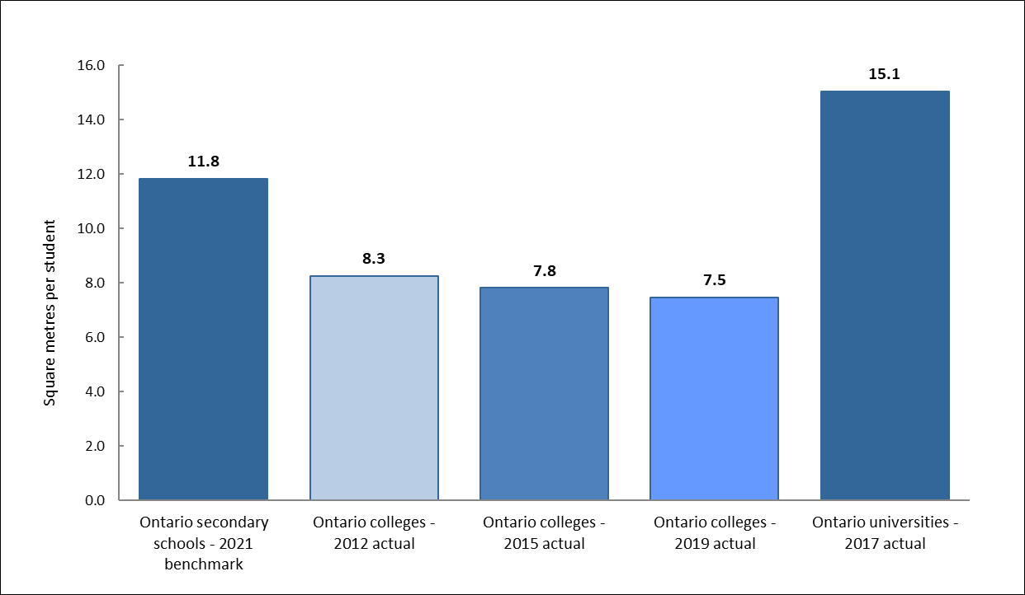

|  |  |
| --- | --- |
| Sources: Ontario Ministry of Education, variable area per pupil benchmark table; Colleges Ontario’s facilities standards and inventory; and the Council of Ontario Universities 2016-17 inventory of physical facilities of Ontario universities.  Prepared by Colleges Ontario. |  |

* Space per student in the college sector has declined since 2012, from 8.3 square metres per full-time equivalent student in 2012 to 7.5 square metres in 2019. The decline is attributable to a slower increase in space compared with enrolment growth.
* From 2012 to 2019, the total space inventory used by colleges increased by five per cent, while enrolment rose by 16 per cent.

## 3.5 Summary of apprenticeship per diem history, 2004-05 to 2020-21

|  |  |  |  |  |  |  |
| --- | --- | --- | --- | --- | --- | --- |
|  | Per diem fee | Student fee | Total apprenticeship budget per student | Ontario CPI (constant 2002 dollars) | Per diem in constant 2002 dollars | Total per student apprenticeship budget in constant 2002 dollars |
| 2004-05 | $53.47 | $10 | $63.47 | 104.6 | $51.12 | $60.68 |
| 2005-06 | $54.74 | $10 | $64.74 | 106.9 | $51.21 | $60.56 |
| 2006-07 | $56.03 | $10 | $66.03 | 108.8 | $51.50 | $60.69 |
| 2007-08 | $56.03 | $10 | $66.03 | 110.8 | $50.57 | $59.59 |
| 2008-09 | $57.35 | $10 | $67.35 | 113.3 | $50.62 | $59.44 |
| 2009-10 | $57.35 | $10 | $67.35 | 113.7 | $50.44 | $59.23 |
| 2010-11 | $57.35 | $10 | $67.35 | 116.5 | $49.23 | $57.81 |
| 2011-12 | $57.35 | $10 | $67.35 | 120.1 | $47.75 | $56.08 |
| 2012-13 | $57.35 | $10 | $67.35 | 121.8 | $47.09 | $55.30 |
| 2013-14 | $57.35 | $10 | $67.35 | 123.0 | $46.63 | $54.76 |
| 2014-15 | $57.35 | $10 | $67.35 | 125.9 | $45.55 | $53.49 |
| 2015-16 | $61.36 | $10 | $71.36 | 127.4 | $48.16 | $56.01 |
| 2016-17 | $63.09 | $10 | $73.09 | 129.7 | $48.64 | $56.35 |
| 2017-18 | $63.09 | $10 | $73.09 | 131.9 | $47.83 | $55.41 |
| 2018-19 | $63.09 | $10 | $73.09 | 135.0 | $46.73 | $54.14 |
| 2019-20 | $65.51 | $10 | $75.51 | 137.5 | $47.64 | $54.92 |
| 2020-21 | $65.51 | $10 | $75.51 | 137.6 | $47.61 | $54.88 |
| **Per cent change 2004-05 to 2019-20** | **23%** |  | **19%** | **32%** | **-7%** | **-10%** |

|  |  |
| --- | --- |
| Note: Per diem and classroom fees are based on the standard six-hour training day.  Sources: Ontario Ministry of Colleges and Universities, Ontario Ministry of Finance and  Statistics Canada.  Prepared by Colleges Ontario. |  |

* In current dollars, the apprenticeship per diem is 23 per cent higher than it was in 2004-05. However, the per diem is seven per cent lower than it was 15 years ago, once inflation is taken into account. The in-school student fee has not increased since its introduction in 2002-03.

# HUMAN RESOURCES TRENDS

## 4.1 College staffing levels (head count), 2020-21

|  |  |  |  |
| --- | --- | --- | --- |
|  | **Full time** | **Part time** | **Total** |
| Academic staff | 7,942 | 15,824 | 23,766 |
| Support staff | 8,090 | 8,242 | 16,332 |
| Administrative staff | 3,421 | 696 | 4,117 |
| **Total** | **19,453** | **24,762** | **44,215** |

|  |  |
| --- | --- |
| Source: College Employer Council.  Prepared by Colleges Ontario. |  |

## 4.2 Number of full-time college staff by category, 2004-05 to 2020-21

## 

|  |  |
| --- | --- |
| Source: College Employer Council.  Prepared by Colleges Ontario. |  |

* Colleges employ close to 44,000 people. The total number of full-time staff at colleges increased by 33 per cent from 2004-05 to 2019-2020.

# STUDENT FINANCIAL AID

## 5.1 Levels of student assistance and number of recipients, college sector **(2009-10 to 2020-21)**



*From 2011-12 to 2016-17, the number of OSAP recipients, includes students who received the 30% Off Ontario Tuition grant (including recipients who applied through a separate stand-alone application for the grant).

**Full-time post-secondary head count (excludes other, sponsored and international students).

## 5.2 Canada-Ontario integrated student loan default rates



|  |  |
| --- | --- |
| Source: Ontario Ministry of Colleges and Universities.  Prepared by Colleges Ontario. |  |

* The default rate reflects the percentage of borrowers who have defaulted on their loans. The rates are calculated at a given point in time, approximately two years after the loans have entered repayment status. Thus, the 2020 default rates represent the loan defaults of 2017-18 borrowers at two years into repayment.

# APPENDICES

## 6.1 Appendix 1. Operating grants and regulated tuition fee revenue per FTE, 2004-05 to 2019-20



|  |  |
| --- | --- |
| Notes:  1Figures exclude collaborative and second-entry nursing, nursing pilot programs, clinical education funding  for collaborative nursing and funding for other organizations.  2Sources for the consumer price index include Statistics Canada and the Ontario Ministry of Finance. Other sources include the Ontario Ministry of Colleges and Universities and Colleges Ontario.  3Tuition set-aside figures are estimates. |  |

## 6.2 Appendix 2. Number of college student assistance recipients, by student type



|  |  |
| --- | --- |
| Notes:  *Up to 2016-17, the numbers included students who received the 30% Off Ontario Tuition grant.  **Starting in 2017-18, the Ministry of Colleges and Universities changed its reporting methodology, going to the number of students issued full-time OSAP awards from the previously used number of full-time OSAP award entitlements.  ***These students are assessed as independent students in the Canada assessment and as dependents in the Ontario assessment.  Source: Ontario Ministry of Colleges and Universities. |  |

## Appendix 3. Average student assistance issued to college students, by student type



|  |  |
| --- | --- |
| Notes:  *Up to 2016-17, the numbers included students who received the 30% Off Ontario Tuition grant.  **Starting in 2017-18, the Ministry of Colleges and Universities changed its reporting methodology, going to the number of students issued full-time OSAP awards from the previously used number of full-time OSAP award entitlements.  ***These students are assessed as independent students in the Canada assessment and as dependants in the Ontario assessment.  Source: Ontario Ministry of Colleges and Universities. |  |

## Appendix 4. Distribution of student assistance recipients by post-secondary sector* and student group, 2019-20



Notes:

|  |  |
| --- | --- |
| *Distribution of recipients attending Ontario institutions.  **These students are assessed as independent students in the Canada assessment and as dependants in the Ontario assessment.  Source: Ontario Ministry of Colleges and Universities. |  |